**GYM MANAGEMENT SYSTEM - PROJECT REPORT**

**1. Introduction**

The Gym Management System is a web-based application designed to streamline gym operations, manage memberships, track attendance, and handle financial transactions efficiently. This system provides an intuitive interface for both admins and members, ensuring smooth interaction and data management.



**2. Objectives**

* To automate gym membership management.
* To provide a structured system for fee collection and financial reports.
* To track member attendance and workout progress.
* To manage supplement store inventory and sales.
* To make interactive, safe, user friendly, dynamic, and maintainable website.
* To generate analytical reports for better decision-making.

**3. Technologies Used**

* **Frontend:** HTML, CSS, JavaScript
* **Backend:** Firebase (for authentication and data storage)
* **Database:** Firebase (Realtime database)

**4. System Modules**

**4.1 Admin Module**

* Admin authentication (Signup/Login).
* Dashboard with an overview of gym activities.
* Manage members: Add, edit, delete members. Send notification.
* Assign fee packages.
* Generate financial and attendance reports.
* Manage supplement store inventory.
* Add Diet Plan Details

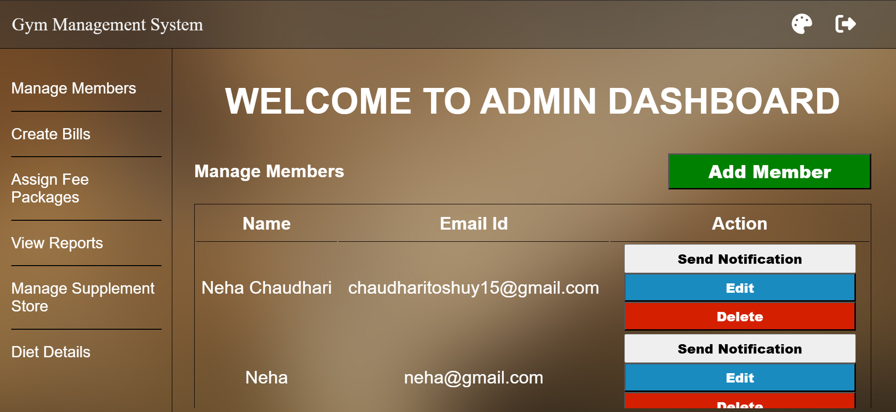

**4.2 Member Module**

* Member authentication (Signup/Login).
* View membership details and payment status.
* Track workout progress and assigned diet plans.
* Purchase supplements from the store.

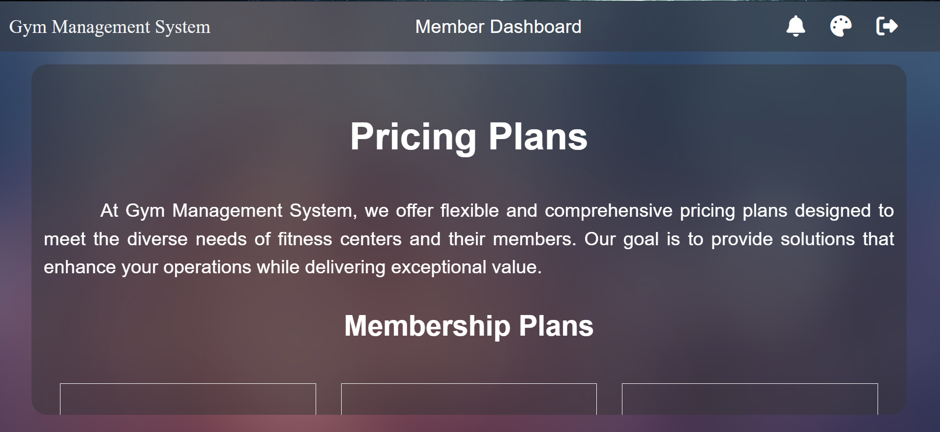

**4.3 Financial Module**

* Automatic generation of bills and invoices.
* Payment tracking and pending dues management.
* Monthly and yearly revenue reports.

**4.4 Reports Module**

* Membership reports (active/inactive members).
* Attendance reports (regular and irregular members).
* Financial reports (revenue, pending payments).
* Supplement store sales reports.

**4.3 User Module**

* User authentication (Signup/Login).
* View Details
* Search Records

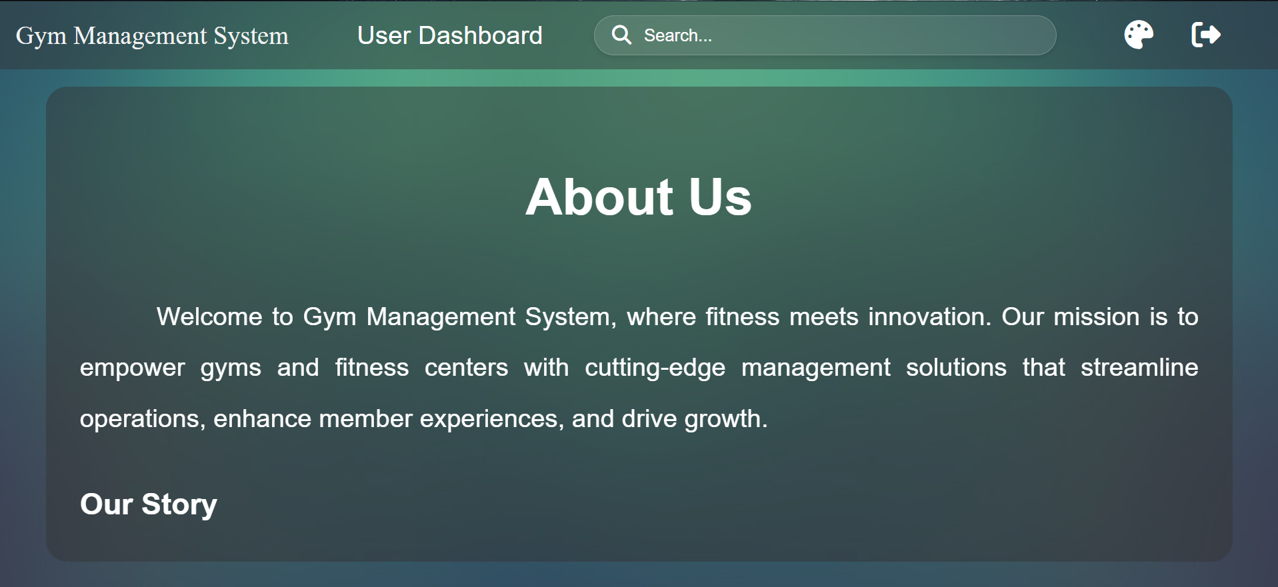

**5. Implementation Details**

* **Home page:** Provides an overview, signup and login options.
* **Admin Dashboard:** Centralized control for gym operations.
* **Member Dashboard:** Personalized portal for gym users.
* **Firebase Integration:** Secure user authentication and data management.

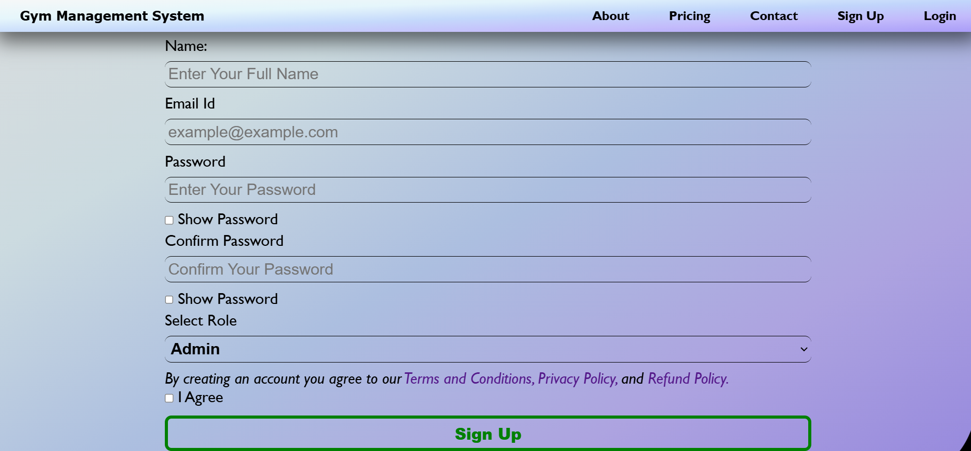

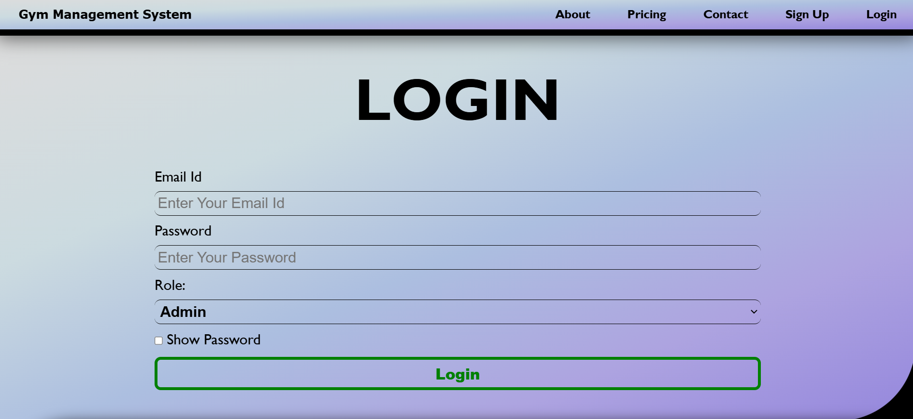

**6. Benefits of the System**

* Reduces manual workload and paperwork.
* Enhances accuracy in financial transactions.
* Provides better tracking of member performance.
* Ensures data security and role-based access.

**7. Conclusion**

The Gym Management System effectively enhances gym administration by automating key tasks, ensuring financial transparency, and improving user experience. With its user-friendly interface and structured data management, it serves as an essential tool for modern gyms.

**8. Reference**

Websites:

* <https://fontawesome.com/>
* <https://chatgpt.com/>
* <https://console.firebase.google.com/>
* <https://unsplash.com/>
* <https://colorhunt.co/>
* <https://www.google.com/>
* <https://www.youtube.com/>
* <https://super-admin.avidtemplates.com/>
* <https://www.wix.com/website-template/view/html/2583?originUrl=https%3A%2F%2Fwww.wix.com%2Fwebsite%2Ftemplates%2Fhtml%2Fhealth-wellness%2Fsports-fitness&tpClick=view_button&esi=2becbf7c-b7cd-49e5-9d87-9afe2cece70e>
* <https://www.w3schools.com/>
* <https://www.geeksforgeeks.org/>
* <https://michalsnik.github.io/aos/>

Tools:

* Visual Studio Code
* Live Server
* Google Chrome Browser

**Cloud Deployment (Firebase Hosting + Firebase Realtime Database)**

**Justification:**

* Firebase is **scalable, secure, and cost-effective**.
* It provides **real-time database updates** and seamless **authentication (Google, Email/Password)**.
* No need for a backend server, as Firebase itself acts as the backend.

**Deployment Steps:**

1. **Frontend Deployment**: Hosted the frontend (HTML, CSS, JavaScript) on Firebase Hosting.
2. **Database Integration**: Stored user and membership details in Firebase Realtime Database.
3. **Authentication Setup**: Managed authentication using Firebase Authentication.

**Test Cases for GYM Management System**

**Login/Signup Page**

✅ **Valid/Invalid Email and Password Handling**  
✅ **Show Password Checkbox Functionality**

**Dashboard Interface**

✅ **Ensures proper UI display**  
✅ **Buttons, links, and forms function correctly**  
✅ **Fully responsive design**  
✅ **Color theme implemented as per the design**

**User Registration & Authentication**

✅ **User details are successfully stored in Firebase**  
✅ **Duplicate entries are not accepted**

**Membership Plan Management**

✅ **Subscription plan updates upon purchase**  
❌ **Expired members are not automatically removed (needs further implementation)**

**Performance Testing (Speed & Load)**

✅ **Website loads within 3 seconds**  
✅ **Firebase real-time sync updates instantly**